Mercy Pedalers

It is a simple concept. Bicycle where you find Sacramento’s homeless and offer friendship and counseling, along with help in connecting to other services. I am a Mercy Pedaler, street photographer and photojournalist. I bike Midtown Sacramento several days a week in the early morning hours. I like to think of it as dawn patrol.

For me Midtown in the early morning hours is all about coffee, cityscapes, “alley art” and the homeless. My images document morning life in the Midtown community, the folks that I meet and the art I find in alleys, parking lots and on the sides of buildings.

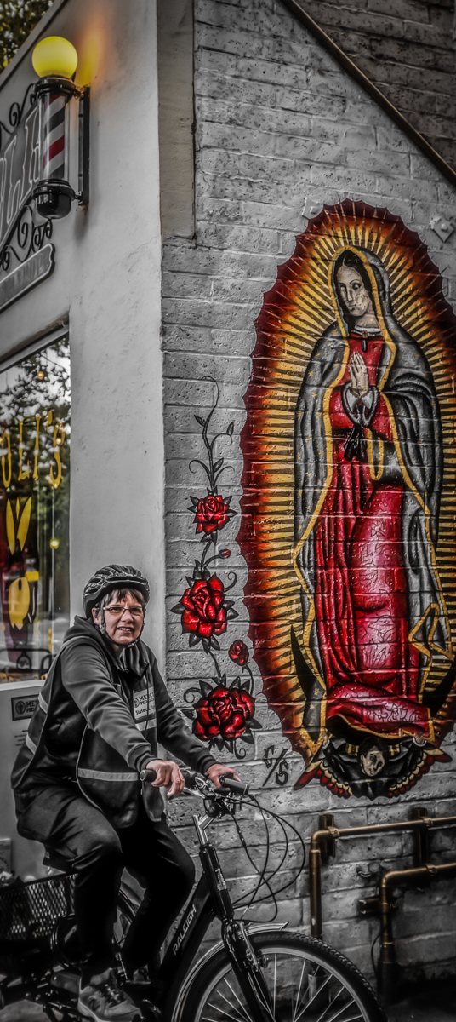
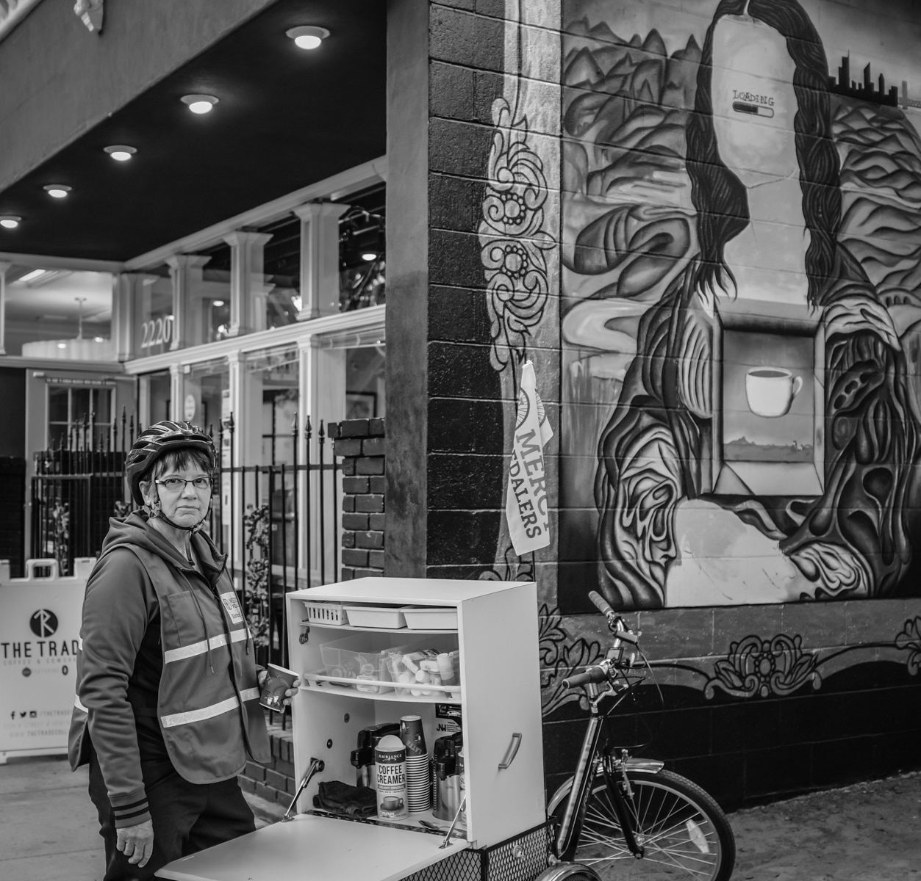
As Sister Libby Fernandez, who started the Mercy Pedaler bicycle ministry, likes to put it, “I found being present in the moment, sharing a cup of coffee together, and calling the person by ‘name’ are the most important gifts one can offer” to the homeless. For me, it is really about presence, trust and sharing a moment in pictures. I think sharing an image with the community and the homeless is one of the most important gifts I can offer.
Sister Libby
The Trade Coffee Shop
Poli’s Barber Shop

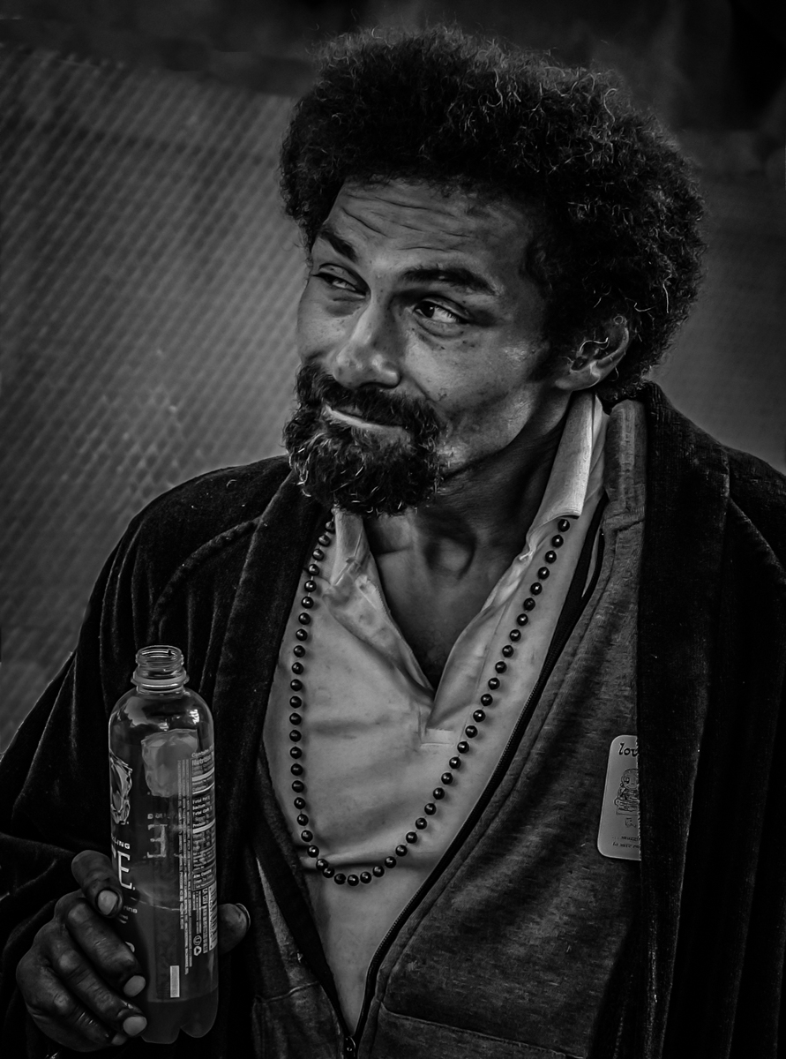
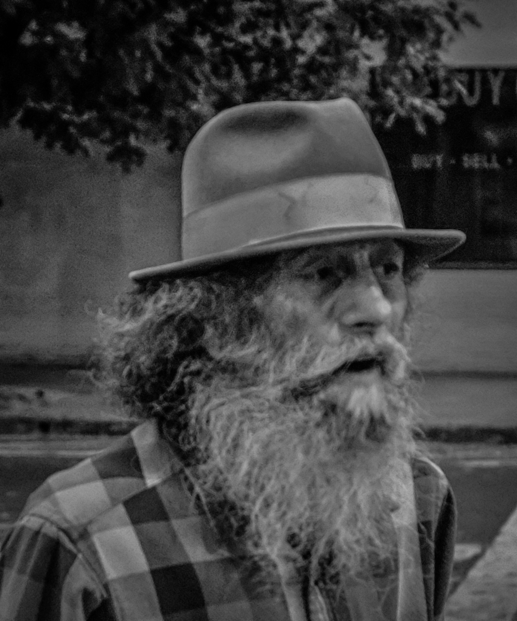
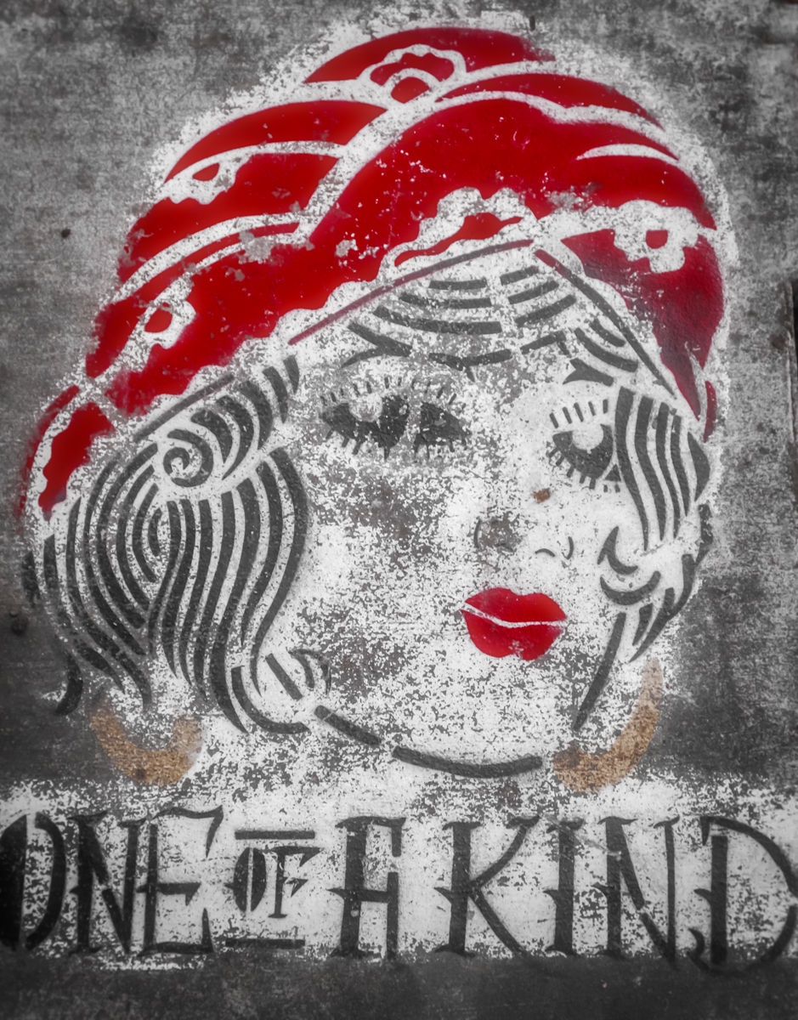
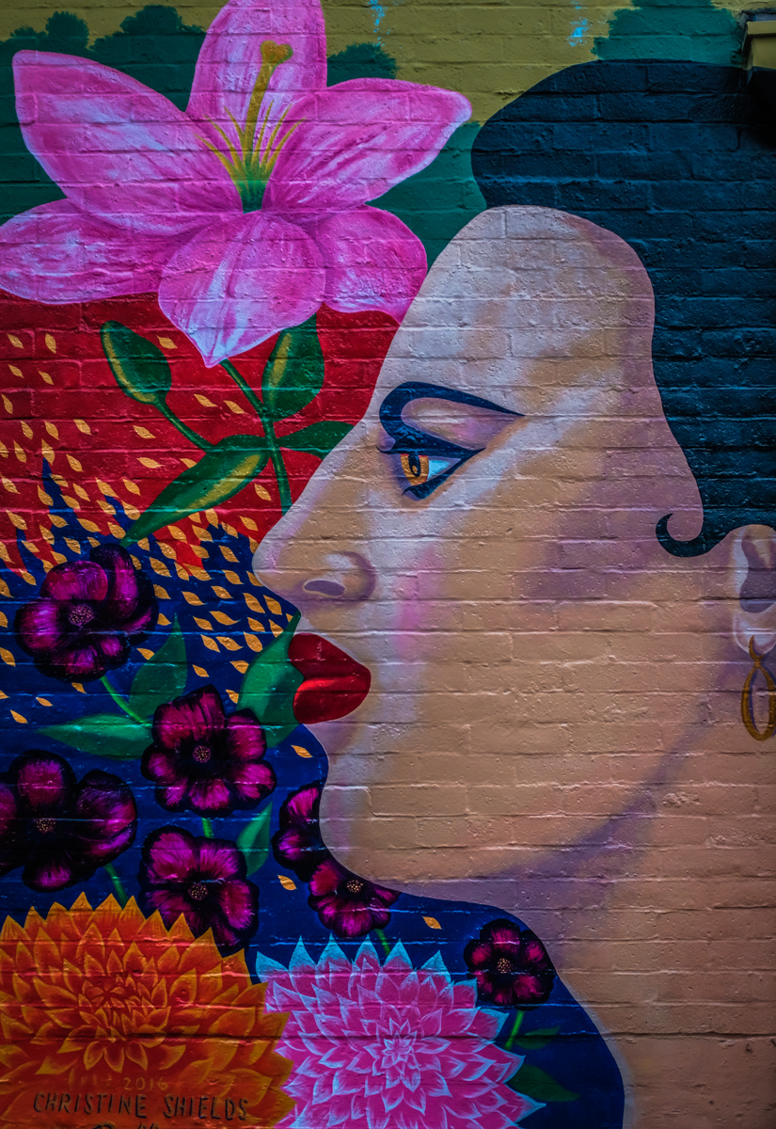
Quentin, 12 years on the streets
Sidewalk art
Tommy, 67 years old. His grandfather gave him the hat when he was 15.
Alley wall mural
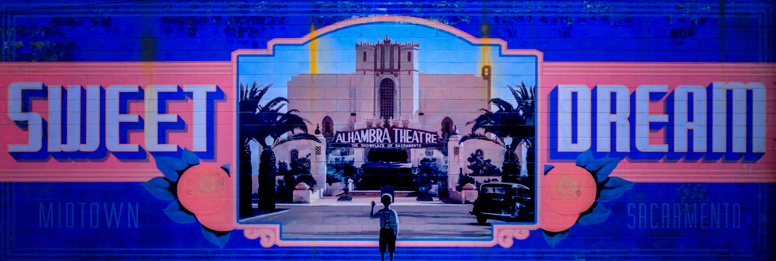
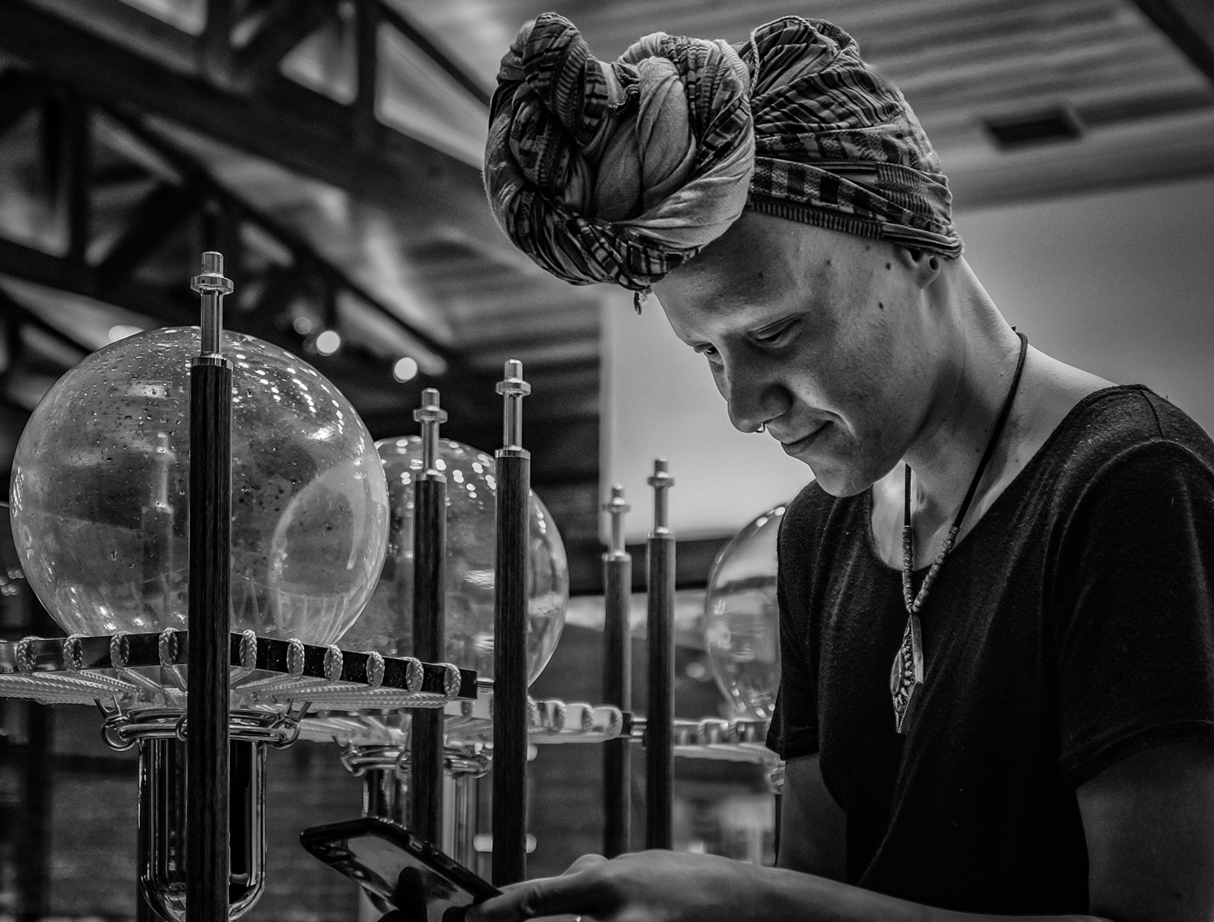
Parking lot mural
Elena, Temple barista

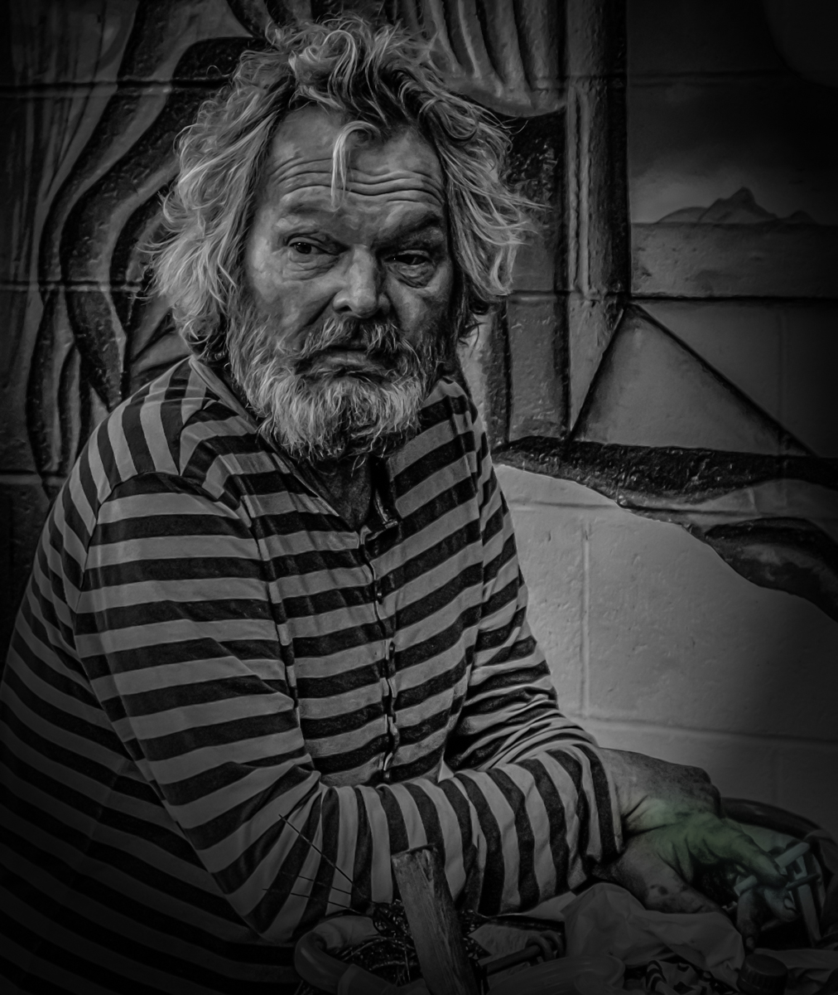
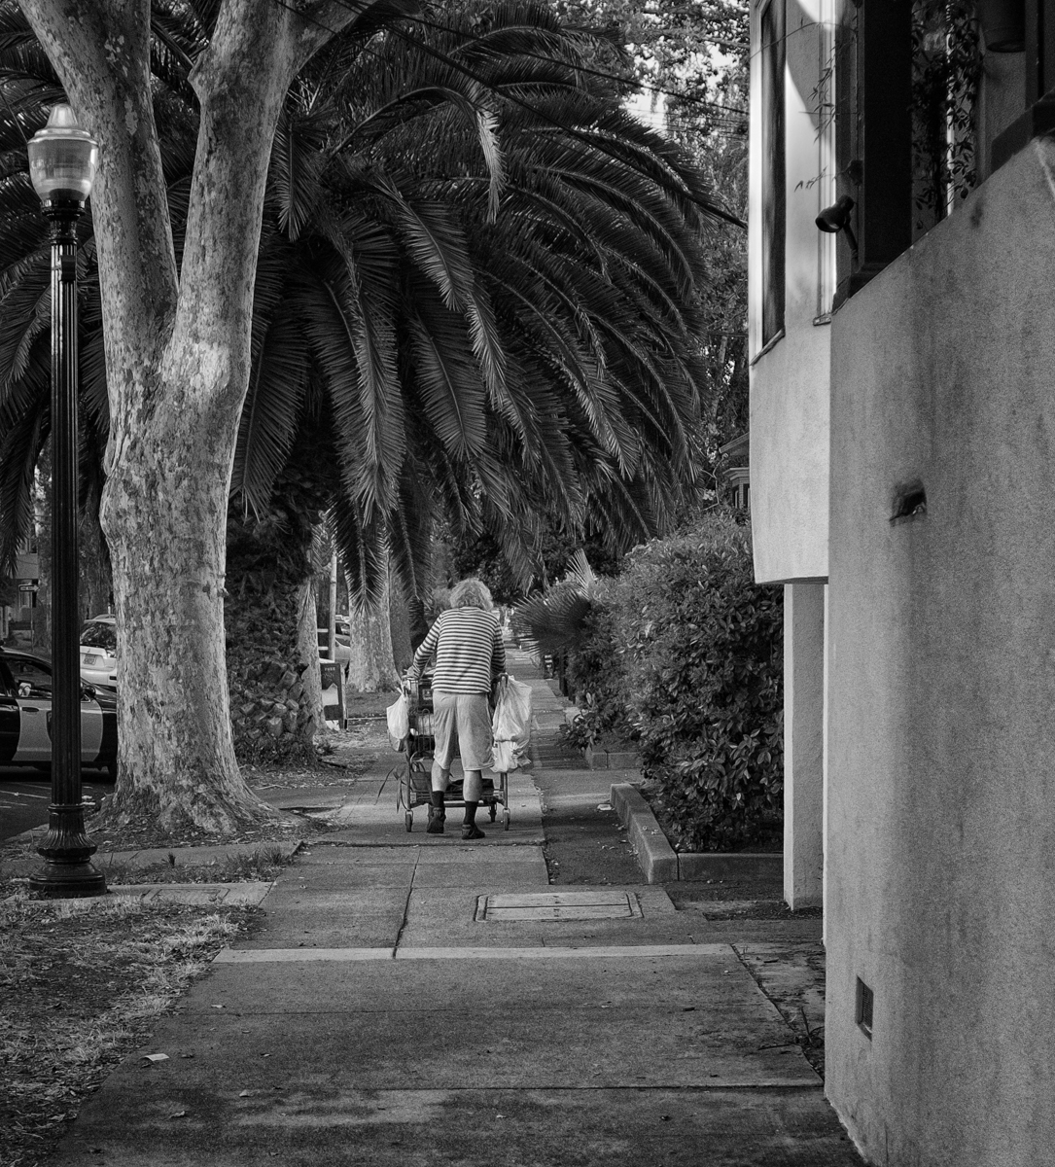
Michael, 10+ years on the street, lives in a Midtown park
David (homeless) and the tiger, wall mural
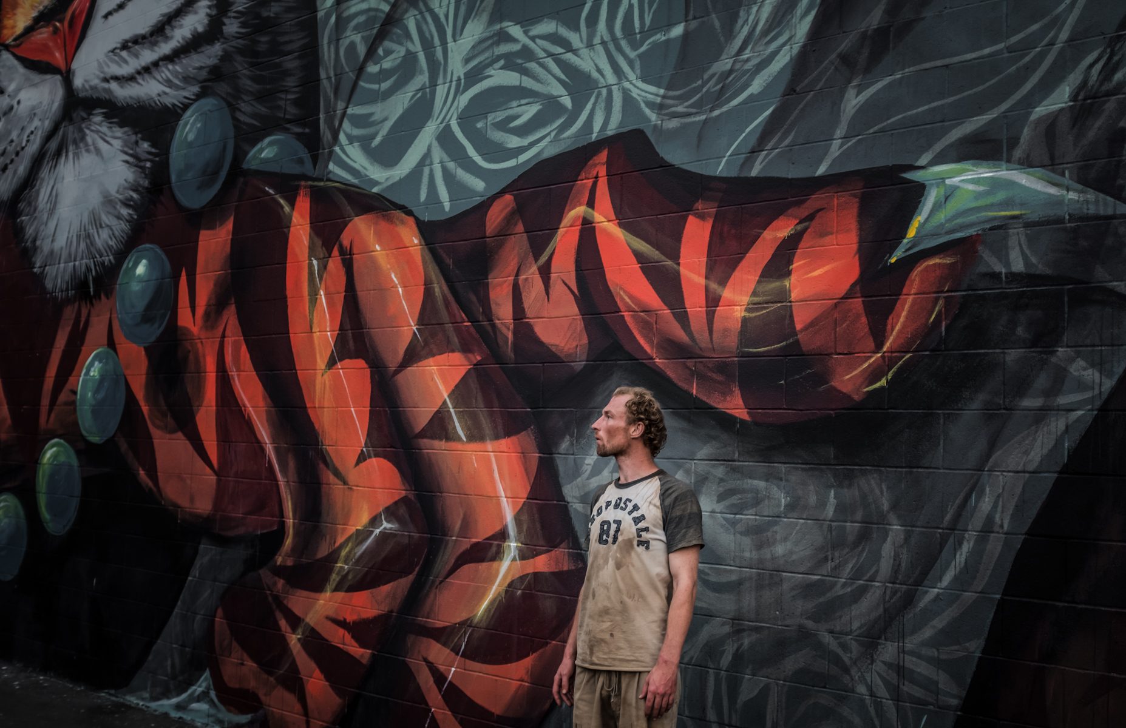
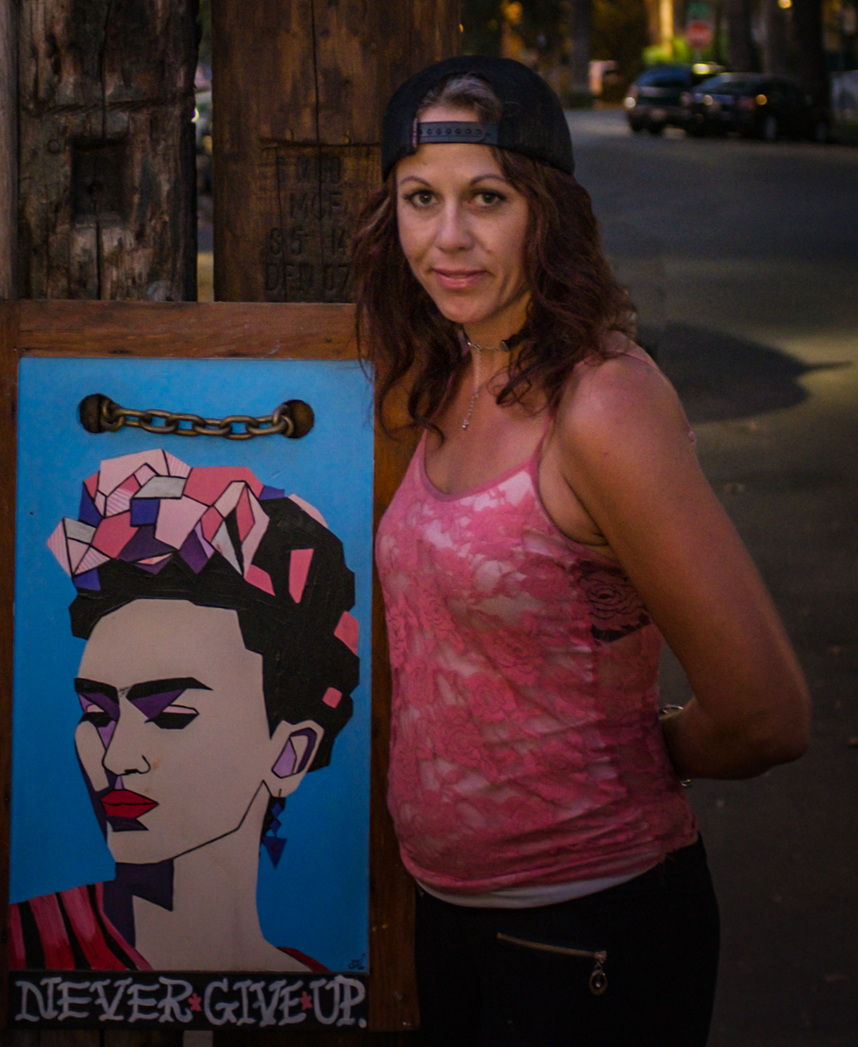
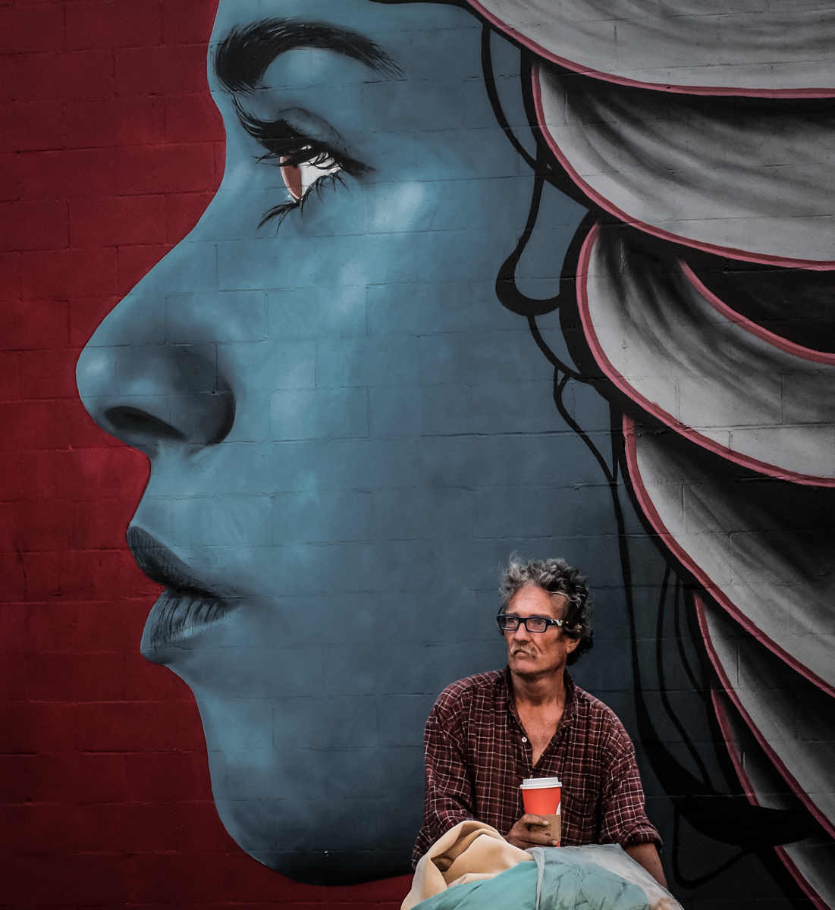
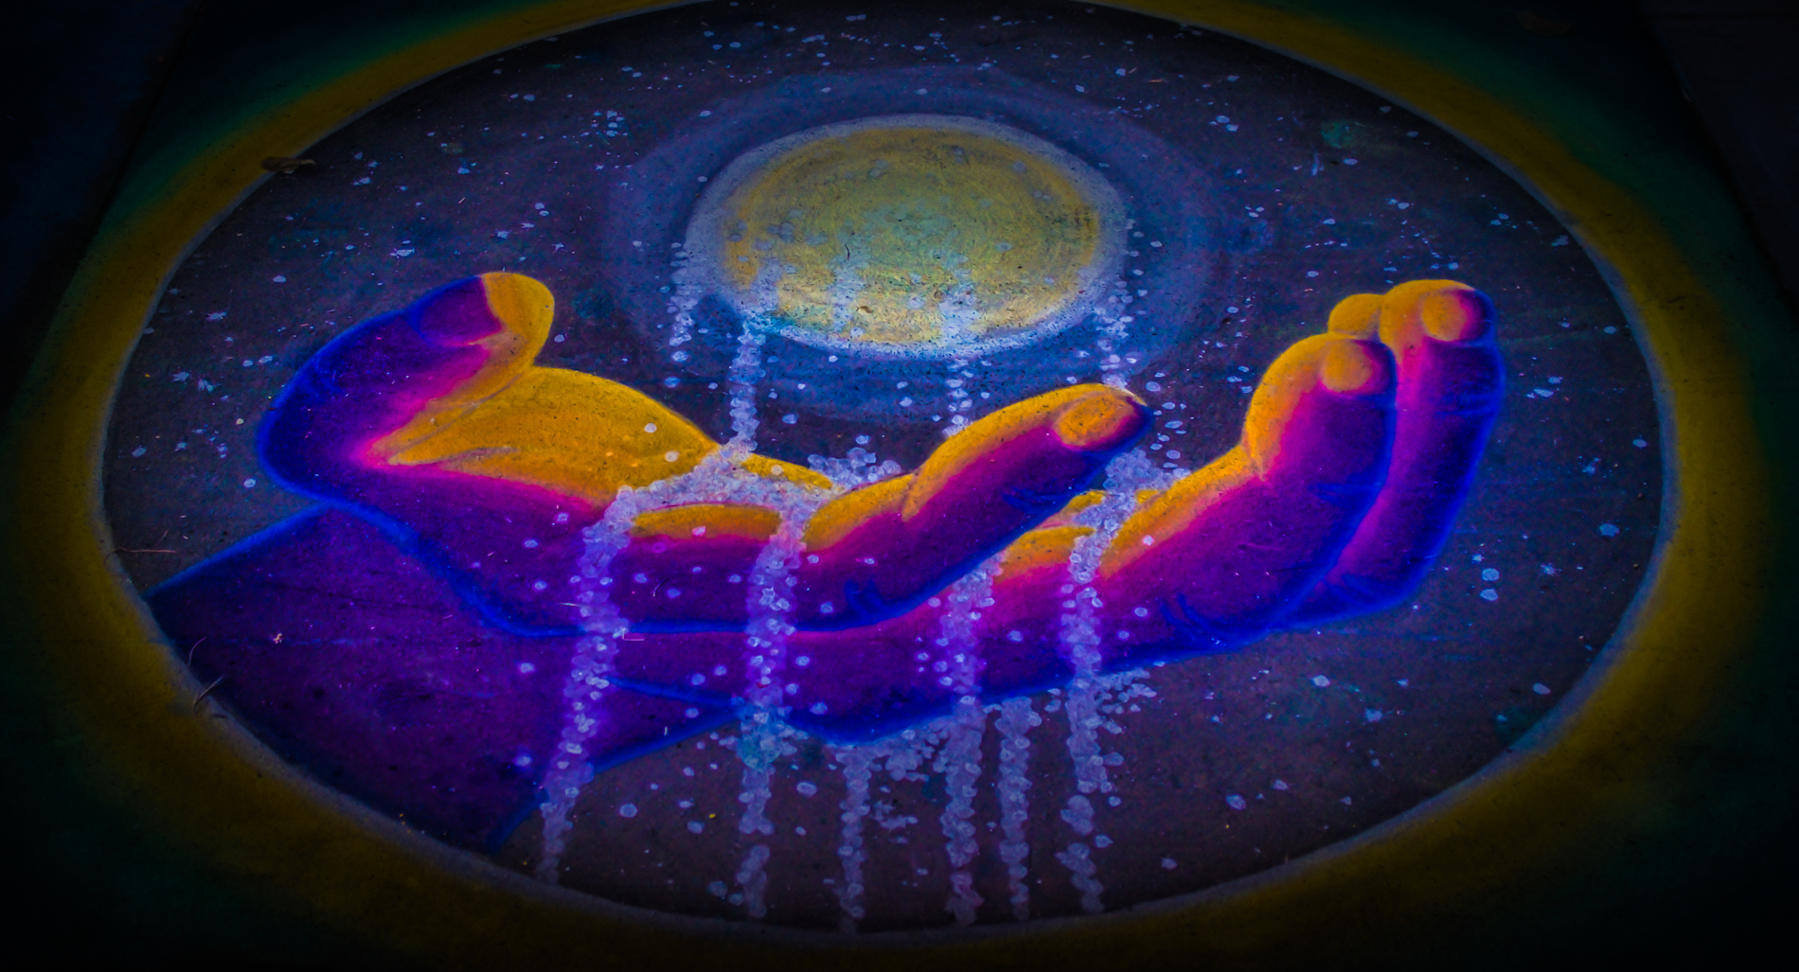
Sidewalk chalk art
Gerry, homeless
Tammy (Homeless) and Frida, pole art

